MAZE GAME CODE

Dim i, j, k, l As Integer
Dim posx(200), posy(200) As Integer

Private Sub Form_KeyDown(KeyCode As Integer, Shift As Integer)
Dim m, flag As Integer

If KeyCode = vbKeyUp Then
'MsgBox "You have pressed UP arrow"
j = 0
For i = 0 To 73
If (((rider.Top - 120) = Line1(i).Y1 Or (rider.Top - 240) = Line1(i).Y1 Or (rider.Top - 360) = Line1(i).Y1) And rider.Left > Line1(i).X1 And rider.Left < Line1(i).X2) Then
j = 1
End If
Next
If j = 1 Then

Else
rider.Top = rider.Top - 480
End If

ElseIf KeyCode = vbKeyDown Then
j = 0
For i = 0 To 73
If ((rider.Top + 360 = Line1(i).Y1 Or rider.Top + 120 = Line1(i).Y1 Or rider.Top + 240 = Line1(i).Y1 Or rider.Top + 480 = Line1(i).Y1) And rider.Left > Line1(i).X1 And rider.Left < Line1(i).X2) Then

j = 1
End If
Next
If j = 1 Then

Else
rider.Top = rider.Top + 480
End If

'rider.Top = rider.Top + 600
'MsgBox "You have pressed DOWN arrow"

ElseIf KeyCode = vbKeyLeft Then
j = 0
For i = 0 To 73
If (((rider.Left - 120) = Line1(i).X1 Or (rider.Left - 240) = Line1(i).X1 Or (rider.Left + -360) = Line1(i).X1) And rider.Top < Line1(i).Y2 And rider.Top > Line1(i).Y1) Then

j = 1
'ElseIf (rider.Left - 120) = Line1(i).X1 And Line1(i).Y2 > rider.Top Then
' j = 1

End If
Next
If j = 1 Then

Else
rider.Left = rider.Left - 480
'rider.Top = rider.Top - 600
End If

'MsgBox "You have pressed LEFT arrow"

ElseIf KeyCode = vbKeyRight Then
j = 0
For i = 0 To 73
If (((rider.Left + 360) = Line1(i).X1 Or (rider.Left + 120) = Line1(i).X1 Or (rider.Left + 240) = Line1(i).X1 Or (rider.Left + 480) = Line1(i).X1) And rider.Top < Line1(i).Y2 And rider.Top > Line1(i).Y1) Then
j = 1
End If
Next
If j = 1 Then

Else
rider.Left = rider.Left + 480

End If

Else

End If

If rider.Left = 7920 And rider.Top = 2160 Then
MsgBox ("You Win!!!!!!")
Timer1.Enabled = False
Timer2.Enabled = False
Unload Me
levelfrm.Show
End If

flag = 0
For m = 0 To k
If posx(m) = rider.Left And posy(m) = rider.Top Then
flag = 1
End If
Next

If flag = 1 Then

Else
posx(k) = rider.Left
posy(k) = rider.Top
k = k + 1
End If
End Sub

Private Sub Form_Load()

Timer1.Enabled = True
Timer2.Enabled = False

Timer1.Interval = 1000
stime.Caption = 5
k = 1
l = 0
posx(0) = 240
posy(0) = 3600
End Sub

Private Sub Timer1_Timer()
If stime.Caption = "0" Then
ghost.Visible = True
Timer1.Enabled = False
Timer2.Enabled = True

Else
stime.Caption = stime.Caption - 1
End If

End Sub

Private Sub Timer2_Timer()

If rider.Left = ghost.Left And rider.Top = ghost.Top Then

'Unload (mazefrm3)
Timer1.Enabled = False
Timer2.Enabled = False
MsgBox ("You Lost!!!!!!")
Unload Me
levelfrm.Show
Else
ghost.Left = posx(l)
ghost.Top = posy(l)
l = l + 1

End If
end Sub
MAZEFRM.VB
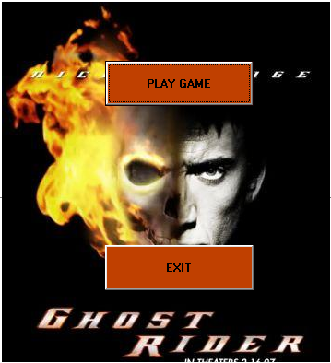

LEVELFRM.VB
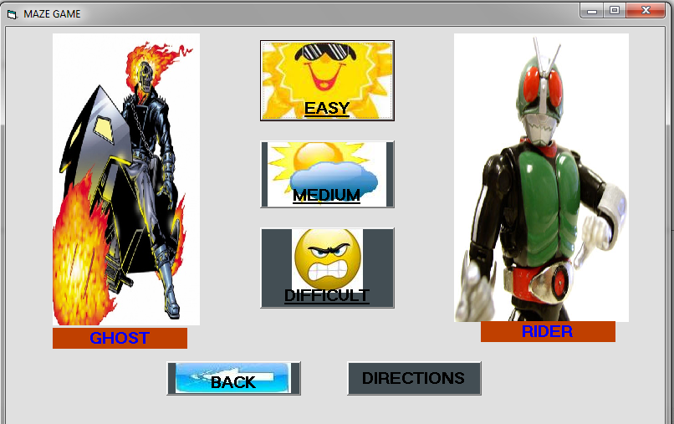
MAZEFRM3.vb
